Let her go
Passenger 2012. Capo 7 deutet auf die 2010er/Songwriterära hin. :). Geschrieben für eine Ex.

Capo 7 75

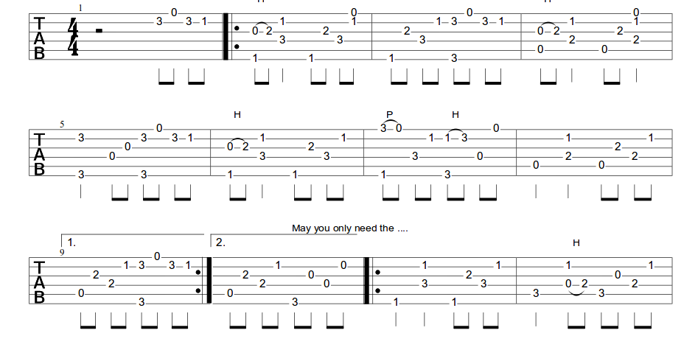
F C
Well you only need the light when it s burning low
G Am
Only miss the sun when it s starts to snow
F C G
Only know your love her when you let her go
F C
Only know you ve been high when you re feeling low
G Am
Only hate the road when you re missin home
F C G
Only know your love her when you ve let her go
Break
And you let her go

Am F G Em
Am F G G

Am F
Staring at the bottom of your glass
G Em
Hoping one day you will make a dream last
Am F G
The dreams come slow and goes so fast
You see her when you close your eyes
Maybe one day you will understand why
Everything you touch surely dies

Chorus

Staring at the ceiling in the dark
Same old empty feeling in your heart
Love comes slow and it goes so fast
Well you see her when you fall asleep
But to never to touch and never to keep
Cause you loved her to much
And you dive too deep

Chorus
Am F G G Am F G G
And you let her go ooo And you let her go ooo
Am F G Em Am F G G
And you let her go

Chorus
Chorus reduced

